User Manual

for

Lightweight Educational Assistant (LEA), Release 1.0

**Version 1.0 approved**

**Prepared by FLAIR**

**Lauren Massey**

**Jessica Updegrove**

**Embry-Riddle Aeronautical University**

**April 26, 2016**

**Table of Contents**

**Table of Contents**

**1 General Information (LAUREN)**

**2 System Summary (JESS)**

2.1 System Configuration

2.2 User Requirements

2.3 Contingencies

**3 Getting Started (LAUREN)**

**4 Using the System (LAUREN)**

4.1 Opening the Application

4.2 Exploring the Menu Options

4.3 Take a Picture

4.4 Understanding the Picture Results

# 1 General Information (LAUREN)

LEA, a small robotic assistant, showcases the Electrical, Computer, Software, and Systems Engineering department (ECSSE). LEA is able to communicate through the speech recognition and hands out pamphlets regarding degree programs offered and scholarship information. She also verbally informs future students and their families about the ECSSE department by providing information about the department, scholarships, and degree programs.

# 2 System Summary (JESS)

This Java application runs an executable .jar file. This section contains the system requirements for running this application successfully.

## System Configurations

This application will run on any Android device that is able to run the Android OS 4.0 Ice Cream Sandwich or newer. The application requires a simple download from the Google App Store for it to be function on any user wanted device.

## User Requirements

To obtain the most acute recognition of a building around campus, the images taken from the device must have a campus building in 70% or more of the selected image. The campus building must have minimal to no obscuring feature in front of it (i.e. trees).

## Contingencies

Remember, as a user, your images taken while using the application are never saved and shared and remain on the device until the recognition is complete, in which they are then deleted.

# 3 Getting Started (LAUREN)

Download the project from the GitHub repository.

If you have an Android device and would like to put the project directly onto it (i.e. without deploying from Android Studio), locate the "debug.apk" file and transfer it to your device. Once on your device, locate the file and click it. This should bring up the default installer - follow the instructions to install the app. If your device hasn't been used in developer mode before, simply follow the instructions on screen to enable developer mode before finishing the app installation.

If you would like to deploy the application to a device, open the project in Android Studio and create a new build configuration with the splash screen as the main class. Make sure your device is plugged in and deploy the project to the device! If there are any problems with the use of Android Studio, please consult the Android documentation and tutorials at <http://developer.android.com/index.html>.

Once the app is installed, go under your main device directory and add a folder called “EagleEyeTempPics”. Once this is added, copy the test.xml and cascade.xml from the source files.

# 4 Using the System (LAUREN)

## 4.1 Opening the Application

## Locate the Eagle Eye icon on your device and tap the icon. Upon loading the app, a welcome screen will be displayed with the Eagle Eye name and vision statement (Figure 1). Within a few seconds, the main screen will be displayed as shown in Figure 2. The application is now ready to use.

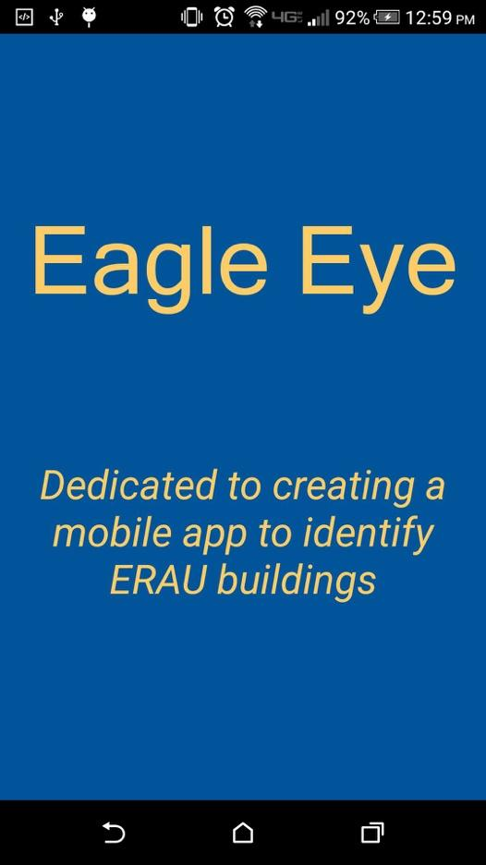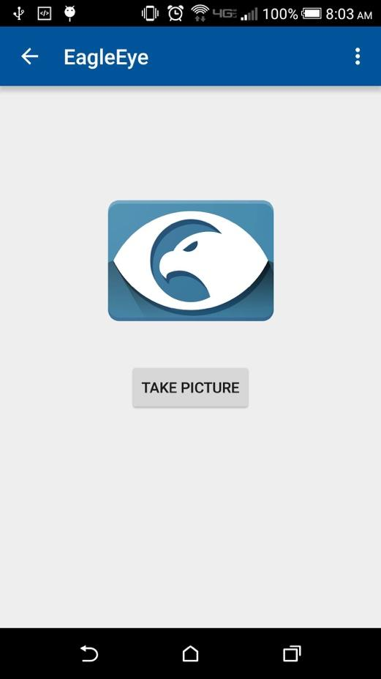

Figure 1: Welcome Screen Figure 2: Main Screen

## 

## 4.2 Exploring the Menu Options

The main screen has two menu options, highlighted as shown in Figure 3.

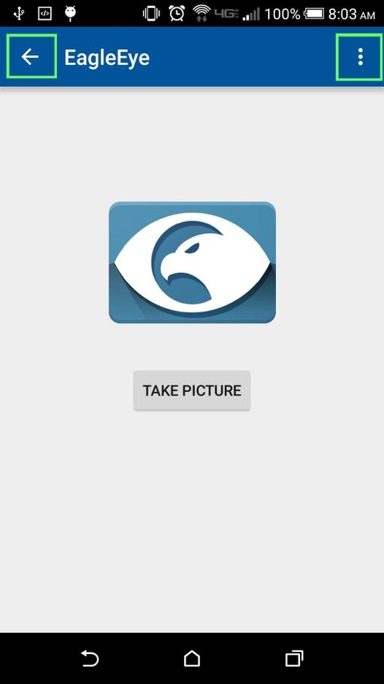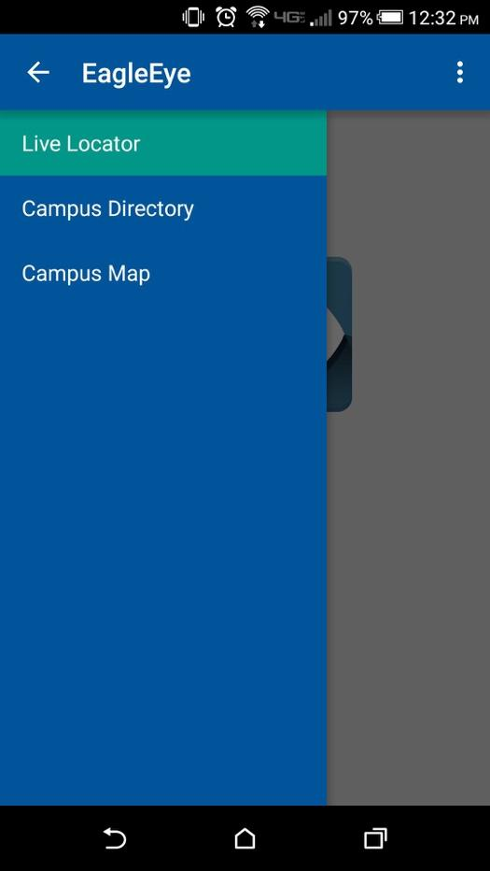

Figure 3: Main Screen with Highlighted Tabs Figure 4: Left-Hand Side Menu

On the top left-hand side there is an arrow pointing to the left. Tapping the arrow will bring up a left-hand side menu with three tabs: Live Locator, Campus Directory, and Campus Map, as shown in Figure 4. The Live Locator tab is the main screen and allows you to take a picture of a campus building. The Campus Directory and Campus Map tabs will be updated in future versions and do not have any functionality at this time.

On the top right-hand side there is an icon with three dots. Clicking this icon will display a submenu with two options: Settings Local and About, as shown in Figure 5. The Settings Local tab has no current functionality at this time. The About screen displays a short description with the developers’ names, a brief description of the app, and how to use the app, as shown in Figure 6.

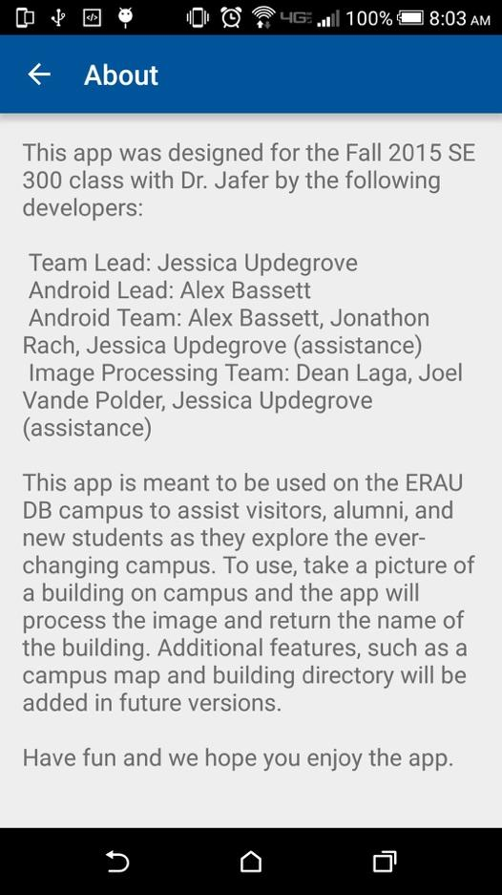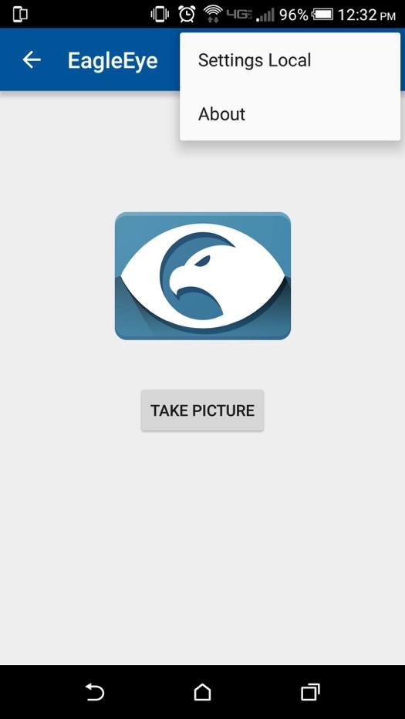

Figure 5: Right-Hand Side Menu Figure 6: About Screen

**4.3 Take a Picture**

On the main screen there is a “Take a Picture” button. To use the app, tap the button. This will bring up your camera which will allow you to take pictures. Take a picture of an ERAU Daytona Beach campus building, with the building taking up at least 70% of the total image. After the image is taken and saved to your device, the application will automatically start processing the image to find a matching result. While processing, informational messages will be displayed alerting you to the progress of the image processing. Please be patient as processing can take up to 1 minute.

## 4.4 Understanding the Picture Results

Once the application finds a match an overlay will be displayed on the screen as shown in Figure 7. The overlay will contain the name of the building in the picture. If a building could not be recognized, you may be too far away from the building or the building may be too obscured. Change your location and take another picture of the building.

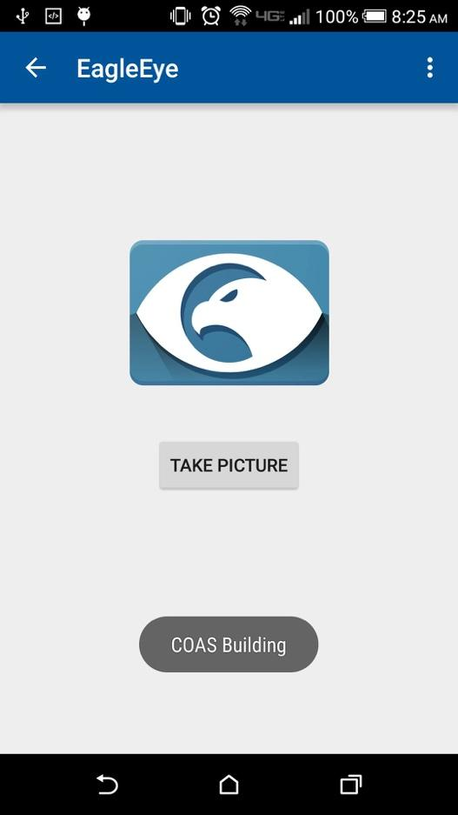

Figure 7: Building Name Overlay